Anomalous Trade (Wash Trade) detection using OCI services and technologies   
  
Hello everyone, this blog post is about our project detecting anomalous trades in real-time. This project is fully built from the ground up on the Oracle Cloud Infrastructure (OCI). This project solves a specific use case of Anomalous Trades known as the **Wash Trades.**

In this Quick read of 10 minutes, we have described the concepts and procedures used in the project, and at the end a quick demonstration of it. To make the readers understand the concepts easily, this read is presented according to the points below:

* At First, we'll understand what a wash trade is and how it is executed.



* Then we'll look at the problem statement and understand why we need an ATD system.
* Then we'll look at what solution we've formed for the said problem.
* Quick look at the standing of our use case with other services in the trading scenario & a look at our MVP architecture.
* And finally, a demonstration of the whole project.

**Now let us see, what is Wash Trading?**



Wash trading refers to an illegal activity in which a single trader buys and sells the same security to generate misleading market information. It is often performed to artificially increase the trading volume of security and mislead investors into believing that trading volumes for security are higher than their actual volume.

**The question also arises: Who is involved in this illegal Wash trading activity?**  
In some situations, Wash Trades are executed by a trader and a broker who is collaborating, but sometimes Wash Trades can be executed by investors who are acting as both the buyer and the seller of that security. For preventing these activities Wash Trades are deemed illegal by section 1091  
of the IRC (Internal Revenue Code), and hence it needs to be detected and reported accordingly.

Wash trade is an illegal activity and can be extremely damaging to the proper functioning and integrity of capital markets as it can mislead the rest of the market about the true level of demand, distort prices and entice others to trade on fake information. Hence, it’s necessary to detect and report the Wash Trades within a short



period after their generation.

As a solution to this problem of Wash Trades, we have created a cloud-native solution for the real-time detection of anomalous trade which comes from the trade stream from financial markets and notifies the concerned Regulatory parties with an email of relevant files attached.

**We could have made this project in an on-premise environment, but why did we choose a cloud-native approach?**



The reason behind this is that our main focus of using a cloud environment is that we have the power of autoscaling, i.e. we can scale up and scale down our resources whenever we want and we don't need to set up the whole physical infrastructure and connection setting on-premise.

In a cloud environment, all the services can connect or communicate with other services. It provides the user with a seamless experience with hassle-free connection settings.

In brief, if we talk about our solution, it takes the stream of trades in Real-time, processes the trades and if any wash trade is identified it stores that trade information and notifies the respective authority regarding the same.

This solution contains the simplified track by using the OCI Services and technologies mentioned below:

* **OCI Object Storage** – Object Storage is used to store Objects. It is a high-performance storage platform that offers reliable and cost-efficient data durability.
* **OCI Streaming** - Oracle Cloud Infrastructure Streaming service provides a fully managed, scalable, and durable solution for ingesting and consuming high-volume data streams in real time.
* **OCI Data Integration** - Data Integration is a fully managed OCI service used to perform extract, transform, and load (ETL) tasks.
* **OCI Data flow** - Data Flow is a fully managed Apache Spark service used to run sparks jobs.
* **Service Connector hub:** OCI Service Connector Hub is a cloud message bus platform that offers a single pane of glass for describing, executing, and monitoring interactions when moving data between OCI services.
* **OCI Spark Streaming** - Spark Streaming, is a real-time processing engine which lets us express computation on streaming data in the same way, we express batch computation on static data.
* **PySpark** - PySpark is the Python API for Apache Spark, an open-source, distributed computing framework and set of libraries for real-time, large-scale data processing
* **Python Language** - Python is a high-level, general-purpose programming language. Python is dynamically typed and It supports multiple programming paradigms like structured, object-oriented and functional programming.

Before going through our MVP architecture, let's take a quick view of the architecture from where we took inspiration to build this MVP, this architecture was taken from the reference architectures section of the Oracle Architecture Centre. The diagram here shows a customer-inspired, modern data platform architecture on Oracle Cloud Infrastructure (OCI).

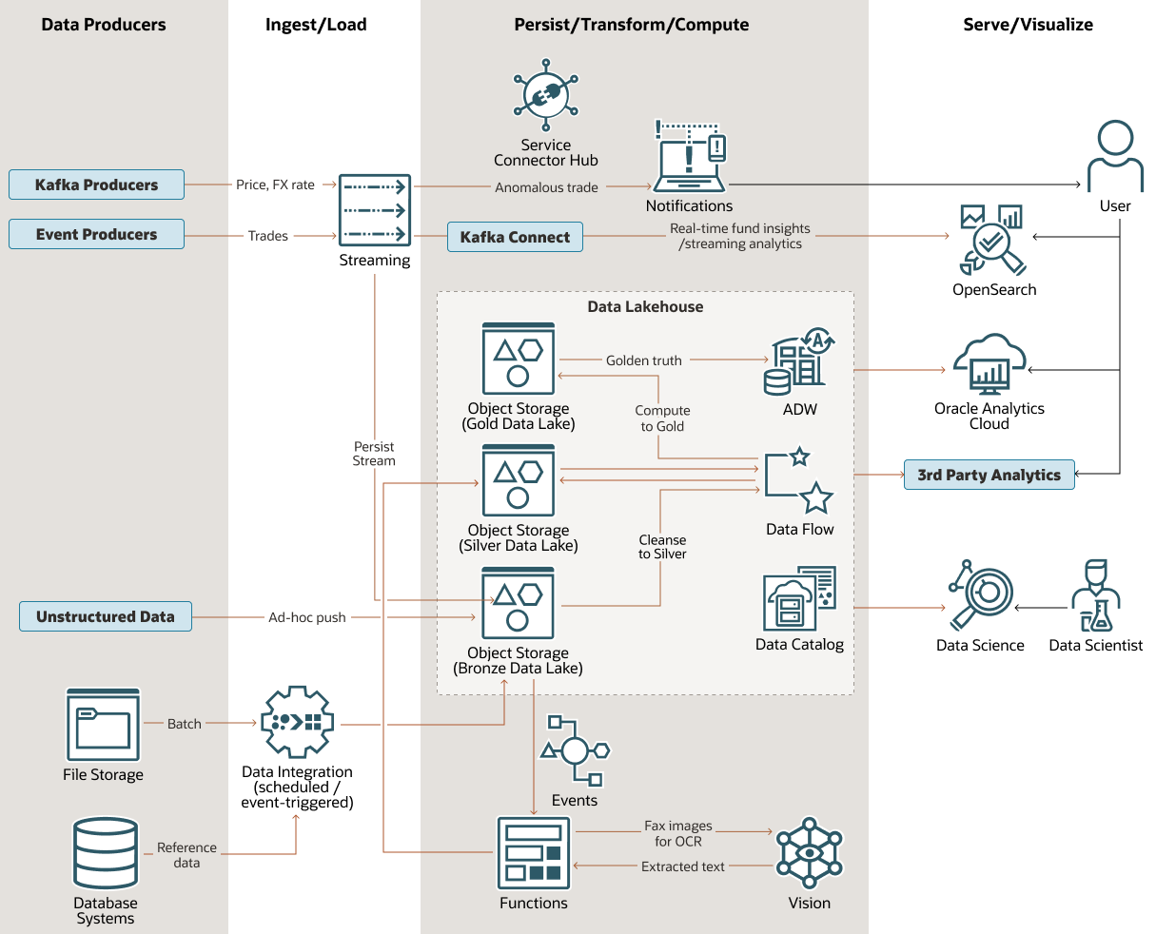

Ref. Link to the solution playbook - [Design a Modern Data Platform for Financial Workloads (oracle.com)](https://docs.oracle.com/en/solutions/oci-finance-lakehouse/index.html)

One of the central features of this architecture is its multi-tiered data lake house. It consists of three distinct levels of data treatment in the data lake, Oracle Autonomous Data Warehouse (ADW) for structured warehousing, Oracle Cloud Infrastructure Data Catalog for metadata and governance, and Data Flow for big data processing and transformation using Spark jobs.This architecture can be used for financial use cases such as those for gaining real-time fund insights, detecting anomalous trades, and general financial data cleansing, aggregation, and visualization. Below is the Architecture diagram that we have implemented in our project.

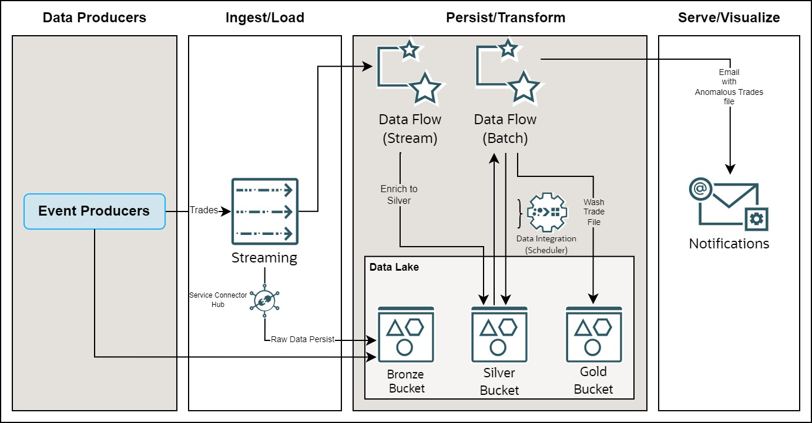

Starting, we have trade data coming in as a stream of trades from Kafka producer code. Our Kafka producer produces streaming data which is ingested by OCI streaming and this code also creates a CSV file of the same streamed data and stores it in a bronze bucket of our data lake. The raw data from stream is also stored in the bronze bucket using the service connector.

OCI streaming suits us perfectly well for our architecture as it's compatible with the Apache Kafka event streaming platform as well as its scalable, durable and fully managed solution for ingesting and consuming high-volume data streams.Now we have an OCI data flow streaming application which ingests data from OCI streaming and inside this data flow, we have a spark application which reads the structured streaming data performs processing for all the incoming trades and adds the time window of 30 sec for each trade and after processing saves the resultant data as a CSV file containing all the trades with their time window in the silver bucket of our data lake.

After this we have a Data integration scheduler service running in intervals of 30 min each which triggers another data flow application which is running spark batch processing.This spark batch data flow application which is triggered every 30 mins by data integration ingests the CSV file which was produced by the streaming batch flow application earlier and performs processing and aggregation based on the fund, security, trade date, and transaction type and gets the market value for all the buy and sell trades, and then marks all the matching buy and sell transactions as Wash Trades and if they fall within 1% tolerance of the market value, lastly we will store these Wash Trades in our data lake’s gold bucket inside a folder named wash trades, this batch data flow application also sends an email notification with the Wash Trades information to a configured email-id, this email contains information about all the Wash Trades which are detected in form of a CSV file.

See below the demo snapshot of each layer of our architecture.

**Data Producers**

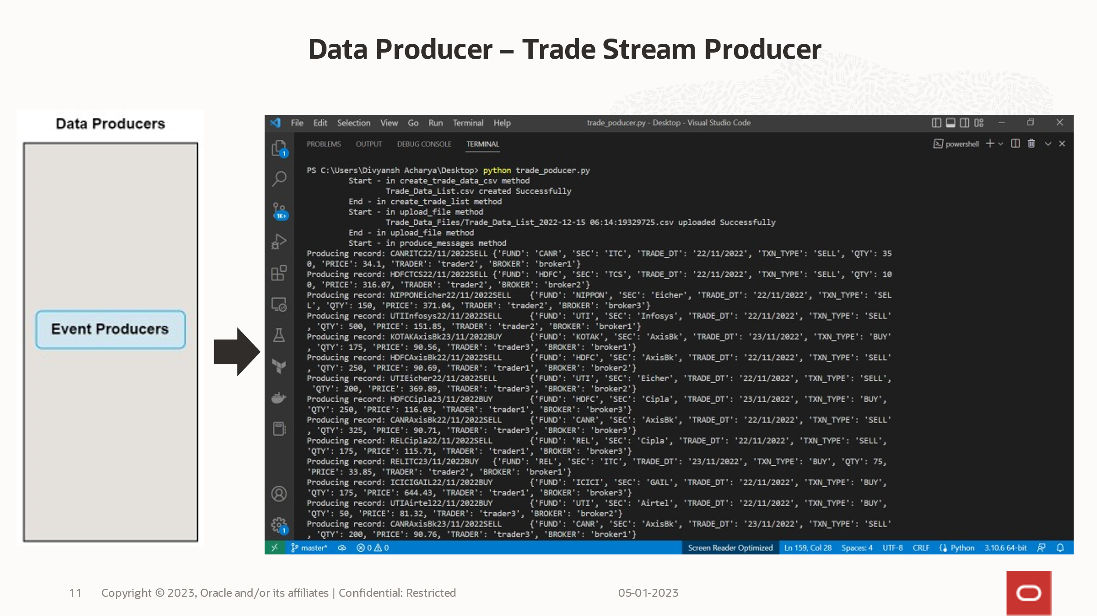

**Ingest/Load**

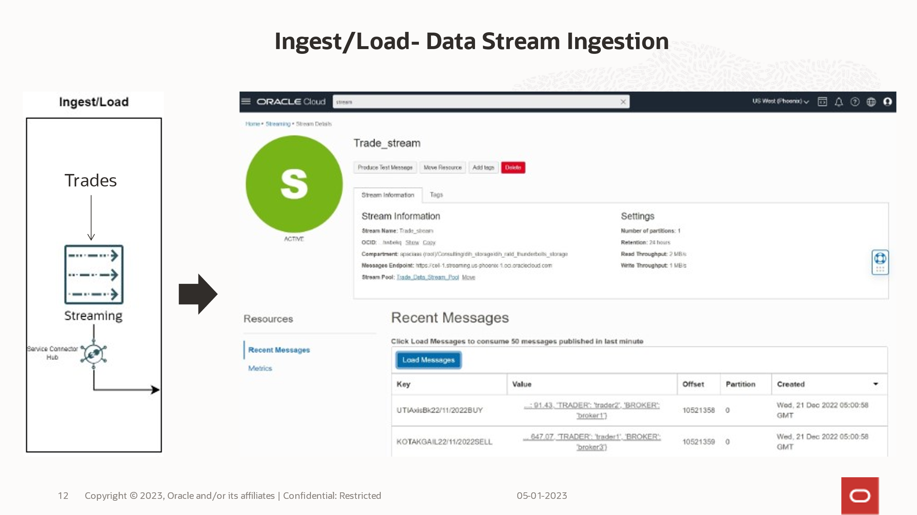

**Persist/Transform – Bronze bucket**

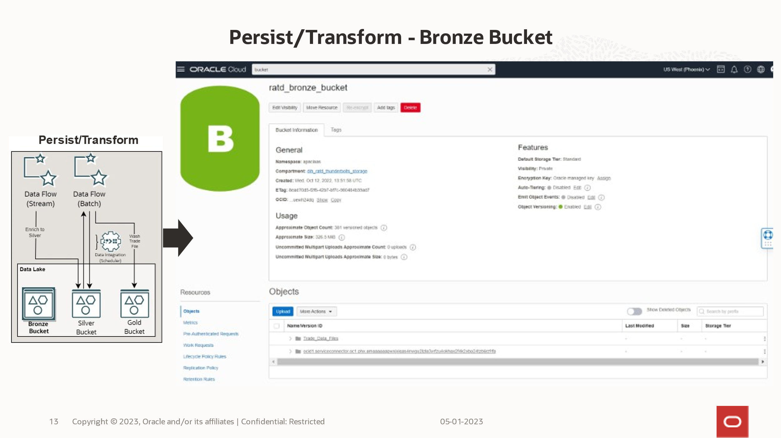

**Persist/Transform – Silver bucket**

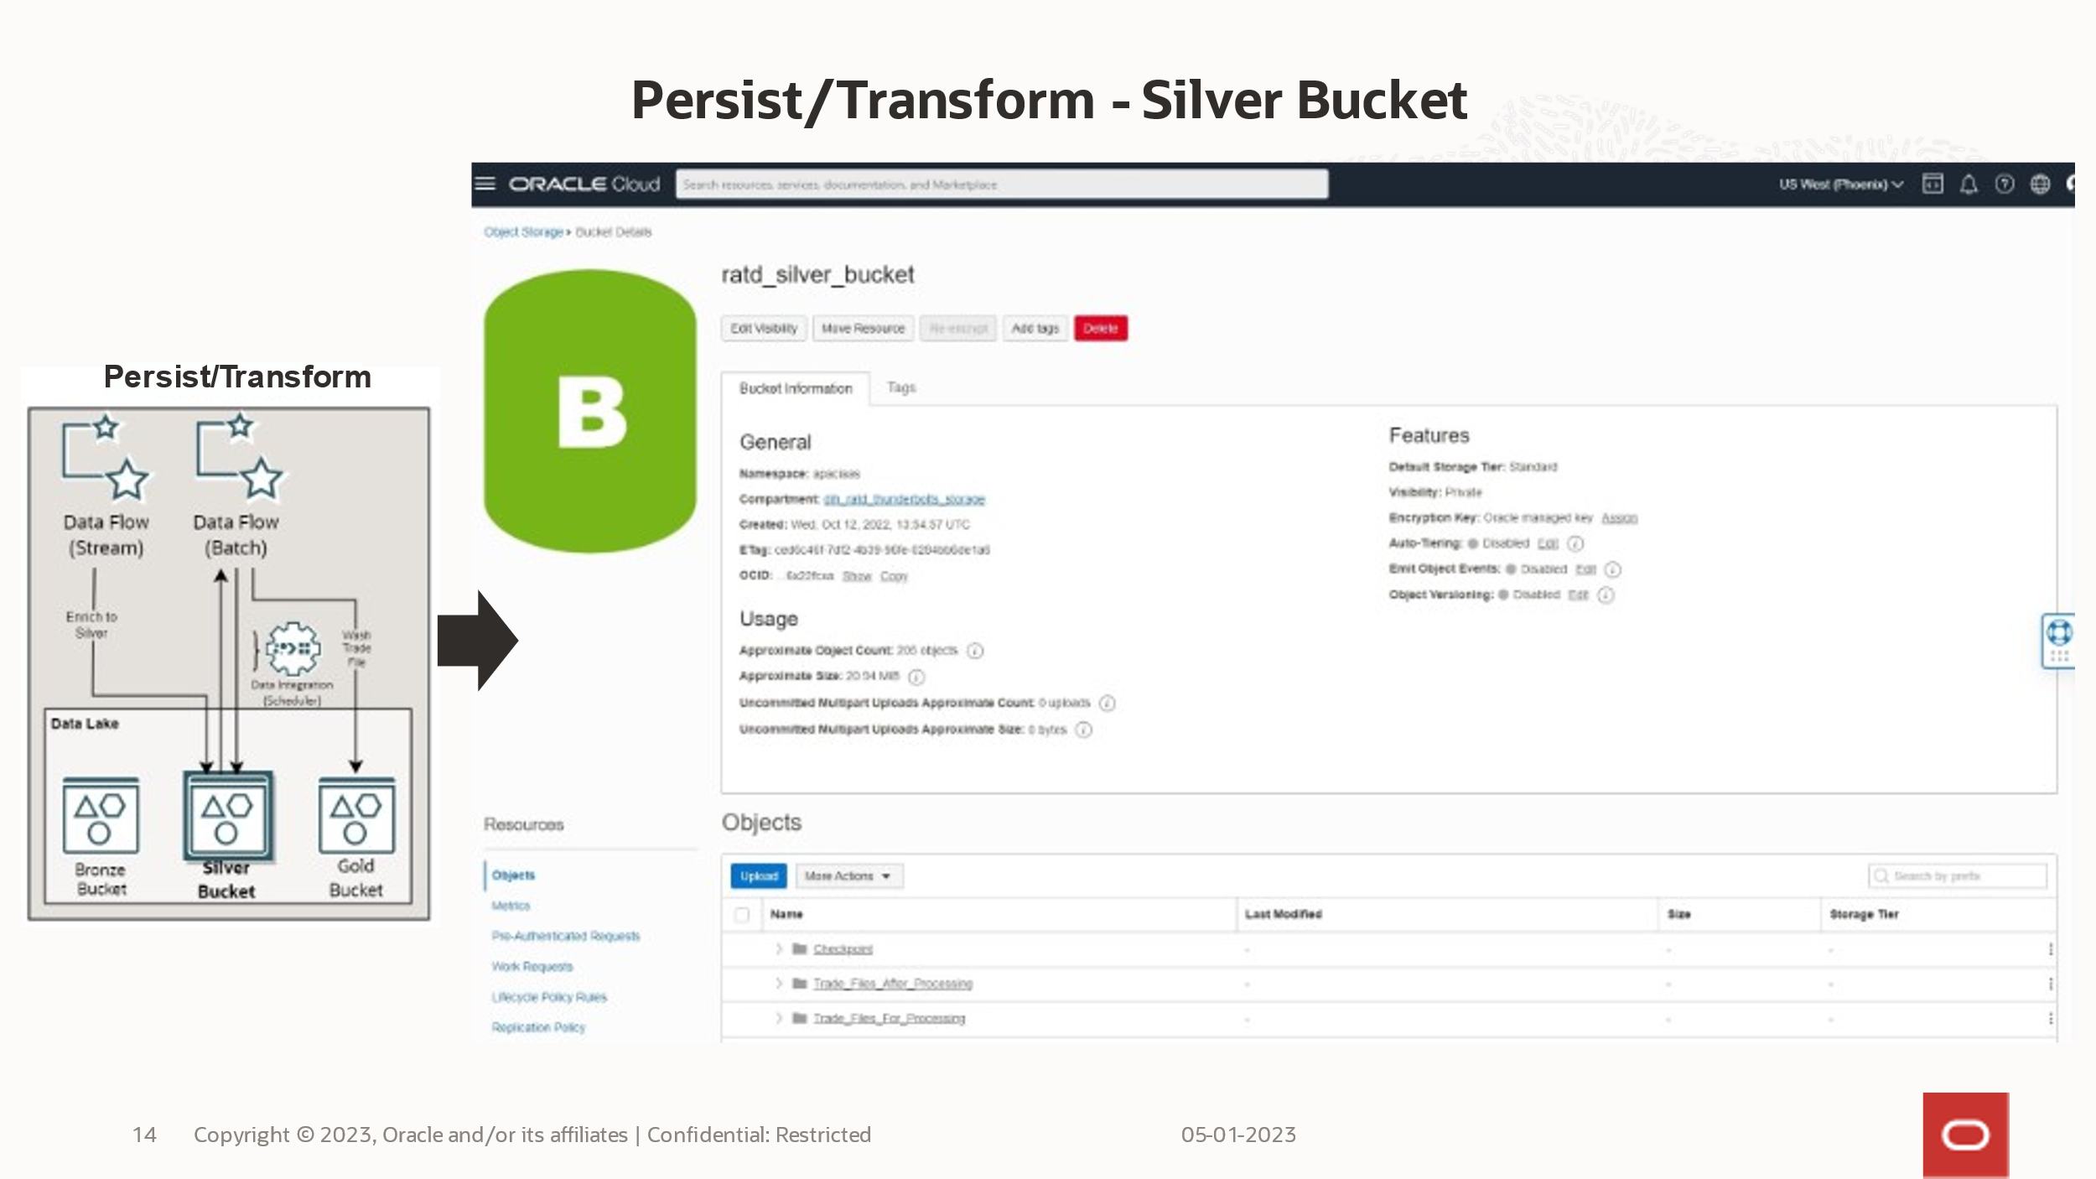

**Persist/Transform – Gold bucket**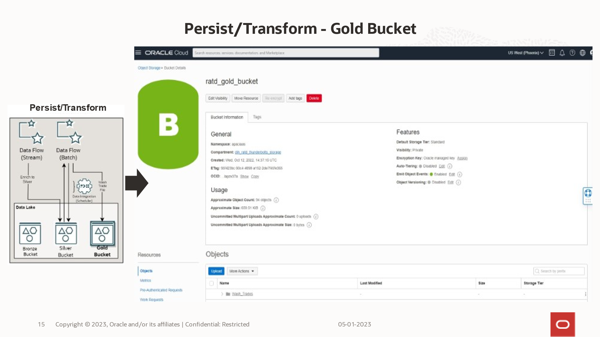

**Serve/Visualize**

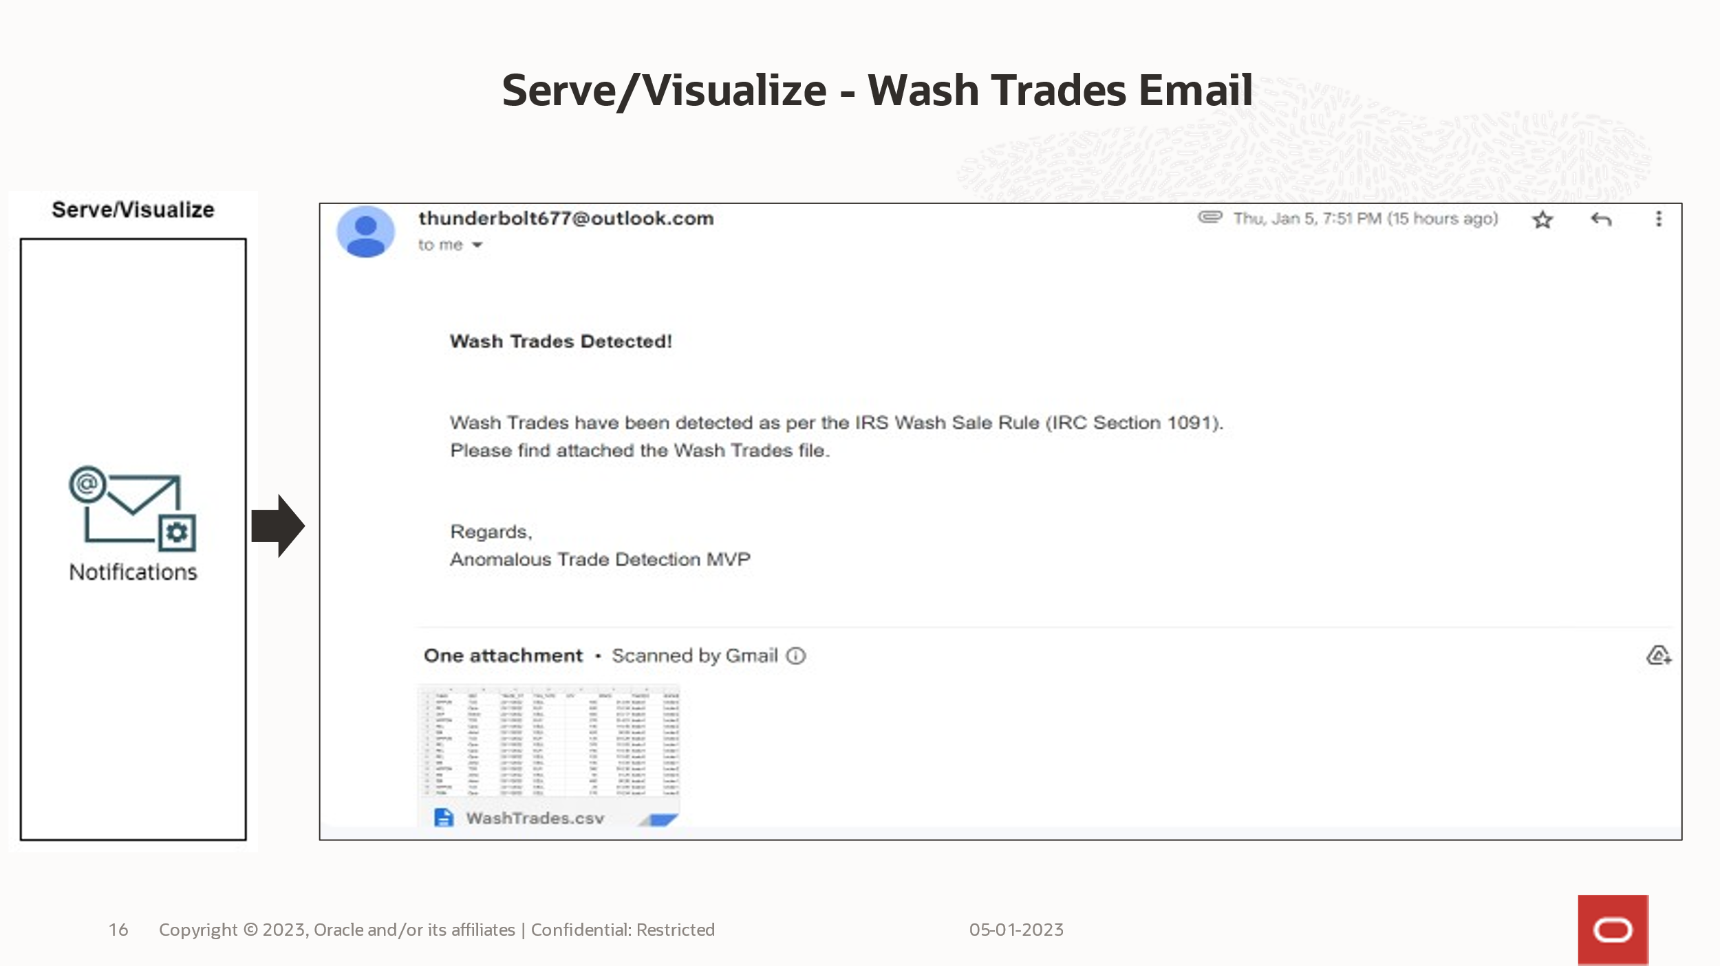

**Email Format**

